Identifying the Taal
Prepared for Indian Classical Music enthusiasts
Prepared by Ishaan Shete
January 17th, 2026
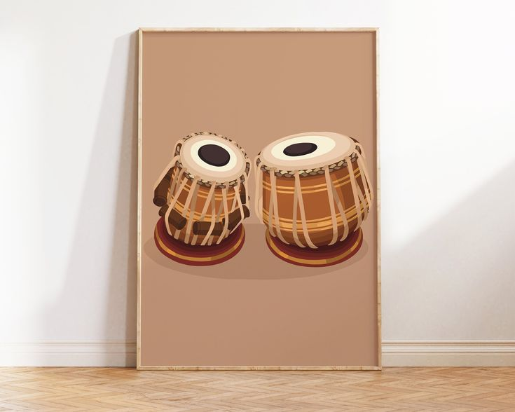
© Image from Pinterest
Table of Contents
Background 2
What is a Taal? 2
How many are there? 2
Why is it significant? 3
How to find the Taal? 4
Listen to the Composition 4
Count the Beats 4
Use the Theka 4
Practice with the Theka 4
Error Handling 4
References 4

Taal identification can be complicated and requires a good amount of experience. This report will cover the basics of what a taal is, where it is found, and how it can be discovered.

Background
This section covers what a Taal is, where it is found, and why it is significant.

What is a Taal?
In Hindustani (Indian) Classical Music, Taal is rhythmic cycle consisting of a fixed number of beats arranged in a specific pattern. These beats are grouped into sections called vibhags. Each Taal has vibhags of distinct characteristics and emphasis. It acts as the rhythmic framework that keeps melodies and compositions in rhythm.

How many are there?
There multiple different Taals in Hindustani Classical Music. Due to the complexity and lack of formal laws, there is no composite total number of Taals available. A composed list of most widely accepted Taals can be found on TablaTheka.com [1]. Below are 3 of the most common Taals found in compostions or performances:

Teentaal
This taal is most basic and commonly found traditional classical compositions.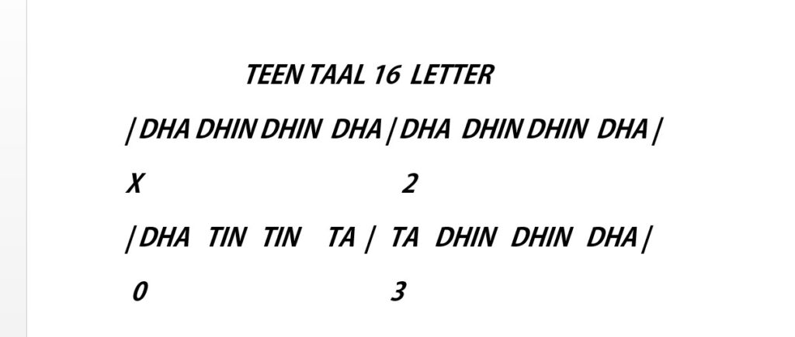
Dadra Taal
This taal is commonly found in songs involving themes of love, longing, and devotional.
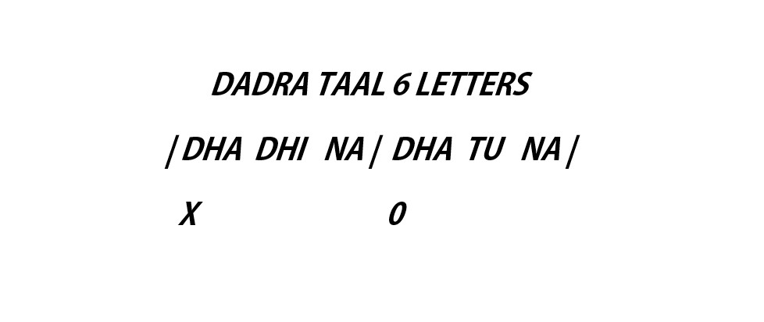
Jhaptaal
This taal is commonly found in short, expressive songs and played during Tabla solo
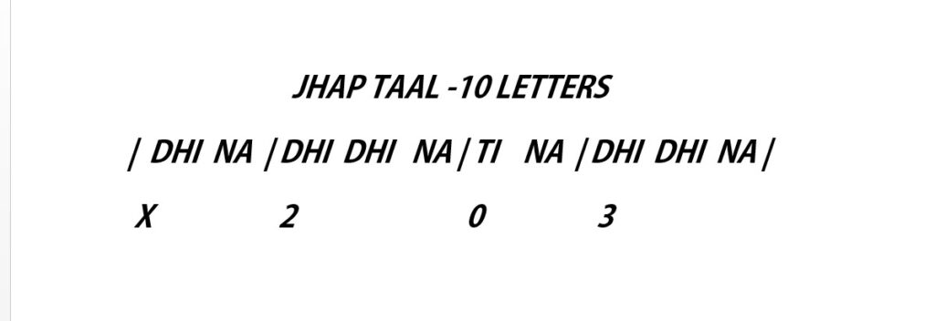

Why is it significant?
Taal is a significant feature of Hindustani Classical Music because it creates the foundation of rhythm. The Taal dictates what rhythm to follow to vocalists, instrumentalists, and percussionists, allowing them to synch in a coordinated manner. Without this, there would be no way to measure time in a composition. Taal also helpers listeners recognize patterns and understand the progression of a performance.

How to find the Taal?
This section explains the basic step-by-step process of Taal recognition.

Listen to the Composition
First step is to carefully listen to a chunk of the composition. When listening, pay attention to the rhythm played by Tabla or other percussion instruments. Try to notice repeating patterns and accents in beats. Note that taals follow a cyclic pattern, so identifying repeating beats is key.

Count the Beats
This is the most important step. After listening for the repeated patterns, try to count the number of beats in each cyclic pattern. The number of beats you count most likely determines the taal. For example, 16-beats most likely indicates it is in Teentaal.

Use the Theka
Theka is the specific drum pattern for each Taal. It is a sequence of bols (syllables); i.e. “Dha Dhin Dhin Dha” for Teentaal. Match what you hear to a known theka to easily determine the Taal being used.

Practice with the Theka
To confirm your results, practice along with the theka. Identify the taal you got based on number of beats and identify its theka. Practice repeatedly saying the theka with the song.

Error Handling
If your theka matches the song, you have found the right Taal! Otherwise, there is possibility you did something wrong.
- Check that you got the correct theka
- Check that you got the correct taal
- Check that you counted the correct number of beats
If you are still unable to figure out the taal, it is best to seek help from an experienced artist.

References
- TablaTheka Hindustani Classical Taals: The Complete Guide | Tabla Theka
- Teentaal Teental - Wikipedia
- Dadra Taal Dadra - Wikipedia
- Jhaptaal Jhaptal - Wikipedia
- Gokhale, Shripad. Tabla Expert. Personal Interview. Jan. 12, 2026.
- Albright, Ravi. Tabla Expert. Personal Interview. Jan. 17, 2026.

